**Java switch Statement**

The switch statement allows us to execute a block of code among many alternatives.

**Syntax:**

switch (expression) {

case value1:

// code

break;

case value2:

// code

break;

...

...

default:

// default statements

}

**How does the switch-case statement work?**

The expression is evaluated once and compared with the values of each case.

* If expression matches with value1, the code of case value1 are executed. Similarly, the code of case value2 is executed if expression matches with value2
* If there is no match, the code of the **default case** is executed

**Note**: The working of the switch-case statement is similar to the [Java if...else...if ladder](https://www.programiz.com/java-programming/if-else-statement#if-else-ladder). However, the syntax of the switch statement is cleaner and much easier to read and write.

**Example: Java switch Statement**

// Java Program to check the size

// using the switch...case statement

class Main {

public static void main(String[] args) {

int number = 44;

String size;

// switch statement to check size

switch (number) {

case 29:

size = "Small";

break;

case 42:

size = "Medium";

break;

// match the value of week

case 44:

size = "Large";

break;

case 48:

size = "Extra Large";

break;

default:

size = "Unknown";

break;

}

System.out.println("Size: " + size);

}

}

[Run Code](https://www.programiz.com/java-programming/online-compiler)

**Output**:

Size: Large

In the above example, we have used the switch statement to find the size. Here, we have a variable number. The variable is compared with the value of each case statement.

Since the value matches with **44**, the code of case 44 is executed.

size = "Large";

break;

Here, the size variable is assigned with the value Large.

**Also Read**: [Create a Simple Calculator Using the Java switch Statement](https://www.programiz.com/java-programming/examples/calculator-switch-case)

**Flowchart of switch Statement**

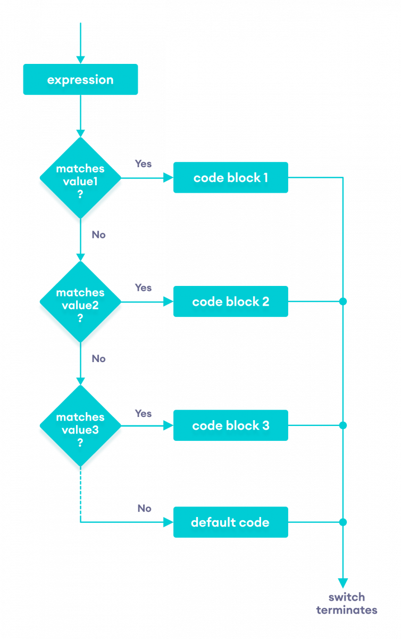Flow chart of the Java switch statement

**break Statement in Java switch...case**

Notice that we have been using break in each case block.

...

case 29:

size = "Small";

break;

...

The break statement is used to terminate the **switch-case** statement. If break is not used, all the cases after the matching case are also executed. For example,

class Main {

public static void main(String[] args) {

int expression = 2;

// switch statement to check size

switch (expression) {

case 1:

System.out.println("Case 1");

// matching case

case 2:

System.out.println("Case 2");

case 3:

System.out.println("Case 3");

default:

System.out.println("Default case");

}

}

}

[Run Code](https://www.programiz.com/java-programming/online-compiler)

**Output**

Case 2

Case 3

Default case

In the above example, expression matches with case 2. Here, we haven't used the break statement after each case.

Hence, all the cases after case 2 are also executed.

This is why the break statement is needed to terminate the **switch-case** statement after the matching case. To learn more, visit [Java break Statement](https://www.programiz.com/java-programming/break-statement).

**default Case in Java switch-case**

The switch statement also includes an **optional default case**. It is executed when the expression doesn't match any of the cases. For example,

class Main {

public static void main(String[] args) {

int expression = 9;

switch(expression) {

case 2:

System.out.println("Small Size");

break;

case 3:

System.out.println("Large Size");

break;

// default case

default:

System.out.println("Unknown Size");

}

}

}

[Run Code](https://www.programiz.com/java-programming/online-compiler)

**Output**

Unknown Size

In the above example, we have created a **switch-case** statement. Here, the value of expression doesn't match with any of the cases.

Hence, the code inside the **default case** is executed.

default:

System.out.println("Unknown Size);

**Note**: The Java switch statement only works with:

* [Primitive data types](https://www.programiz.com/java-programming/variables-primitive-data-types#data-types): byte, short, char, and int
* [Enumerated types](https://www.programiz.com/java-programming/enums)
* [String Class](https://www.programiz.com/java-programming/string)
* [Wrapper Classes](https://www.programiz.com/java-programming/wrapper): Character, Byte, Short, and Integer.